To complete your background check and Safesport requirements, follow the instructions bellow.
Log into your account. The username is your email address you put on the form or set up the account with online, the password for most is soccer123 if that does not work reset the password.

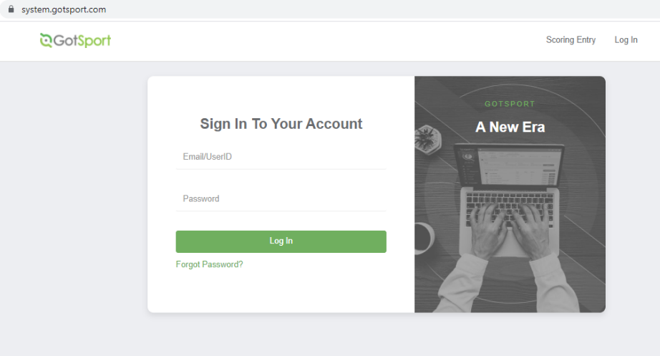

In your account, select the requirements tab. Then select which requirement you need to complete. The background check you will input your name, dob, and social security number. Answer the 3 questions in the box to the left, scroll down, click the information is not false, click submit.

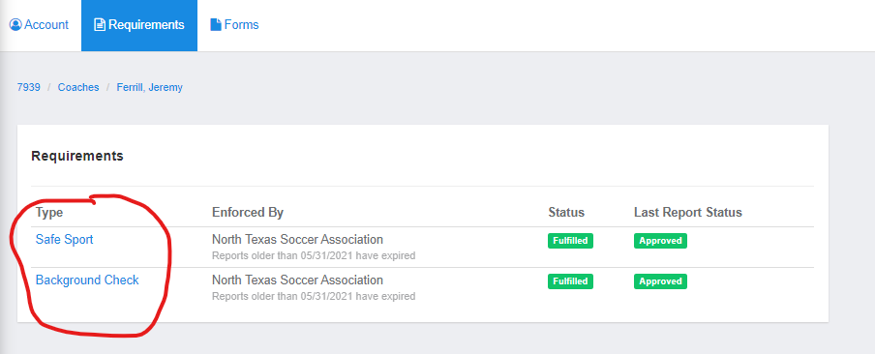
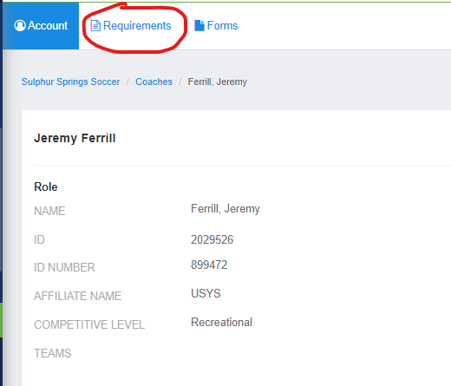

Select the Safe Sport tab. Enter the code for the Safe Sport certification. Note: Do not copy and paste, it will not work. After the code is entered select start course. You will then be redirected to the Safe Sport page. When setting up the Safe Sport account be sure to enter your NAME, EMAIL, AND DOB exactly as it is listed in your gotsport coach account. If you do not do this, it will not link to your coach account. Be sure to safe a copy of completed course certificate in case it does not link to the coach account.

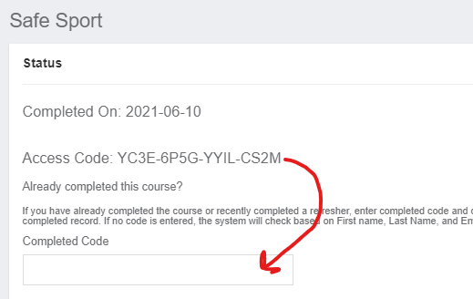

If you run into problems email registrar@sulphurspringssoccer.org

